F-ZERO (1990, Super Nintendo), Nintendo. GAMEPLAY MODE

1. Composition
Tangible space | In full-screen
Intangible space | Intangible visual displays are overlaid upon the tangible space
Negative Space | There is no negative space
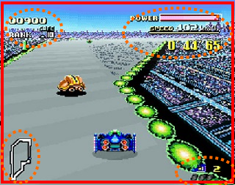
External | Zero Ergodic
2. Ocularization

3. Framing mechanisms | Anchor : Subjective | Mobility : Connected

4. Plane Analysis
 | Agents | In-game | Off-game
Graphical materials | Raster | Raster | Raster
Projection method | Orthogonal | Linear | Linear
Angle of projection | Horizontal | Overview | Overview

Notes :
The in-game environment (highlighted in yellow) is comprised of two distinct types of areas: the race track, which is the playable space, delimited by a full line, and the ground outside the rails, which acts as a bottomless pit (players are instantly destroyed if they land in there), outlined by a dashed line.

Also, the game highlights the Mode 7’s strategy to induce an effect of depth by way of fore-shortening. Even without polygonal 3D, the real-time adjustment of sizes on two axes creates an “allegorical” Z axis that is relevant to the game’s intelligibility. Hence the idiom: “2.5 D”.
